**Sitemap**

A sitemap contains all documents—in other words, webpages—of a website, and presents them hierarchically. This means that **the structure of the entire web presence** is duplicated in this overview. To understand it, you should briefly familiarize yourself with the set-up of a website: a basic website is comprised of individual HTML documents, which are stored in various folders and interconnected via hyperlinks. All of them together are found on the webspace. In the sitemap, pages are recorded along with corresponding URLs.

In the early days of the World Wide Web, the sitemap was principally created to make users’ website navigation easier. Often inserted as a frame in addition to the main content, sitemap documents gave visitors the opportunity to move from one site to another at any time, without having to click through individual hyperlinks one after the other. Nowadays, the navigation process is usually solved much more elegantly, but the sitemap is still justified. For one thing, having this additional navigation tool can **increase user-friendliness**, and for another, search engines make use of these files.

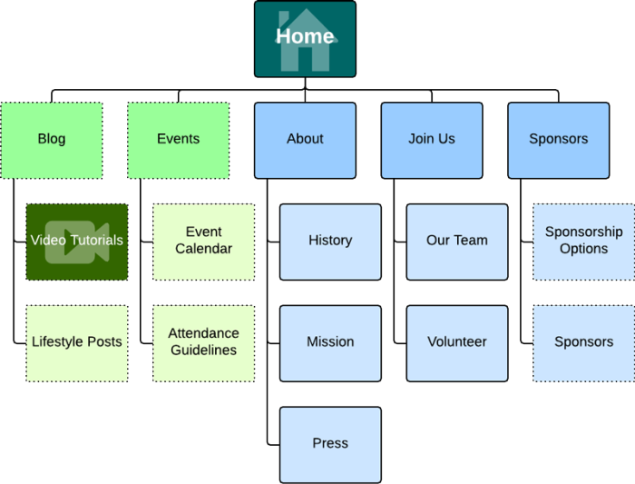

reference: https://www.ionos.com/digitalguide/websites/website-creation/sitemap/